The Paddle Wheel reloaded

Everybody knows the classic paddle wheel. It is submerged partially in water, the rest of it rotates in the air. Due to the different density of these two elements it produces thrust.
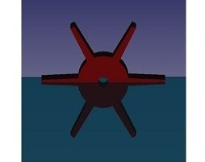
But there is another way for this paddle wheel to produce thrust. The trick is simple: One halve of the paddle wheel has to be covered.
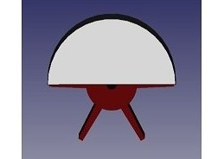
Then the complete assembly can be submerged under water. The covered part of the paddle wheel cannot interact with the water, as if it was not existing (besides some remaining friction). Only the uncovered part interacts with the water and produces thrust.
It is clear that such an arrangement works not only with a horizontal axle but in any orientation.
It seams unbelievable, but it is real and it is that simple and it is an undeniable fact, proven by the several model ships I built:
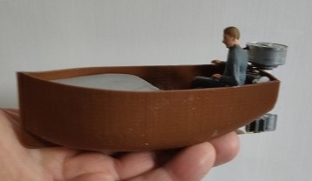
http://www.thomas-uhlendorf.de/Dinghies/Dinghies.htm

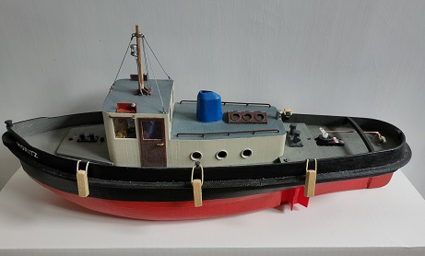
http://www.thomas-uhlendorf.de/Moritz/Moritz.htm

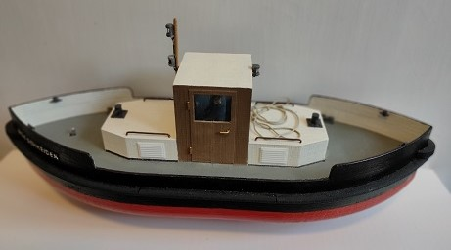
http://www.thomas-uhlendorf.de/VonSchneider/VonSchneider.htm

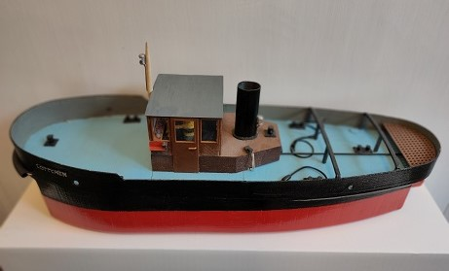
http://www.thomas-uhlendorf.de/Lottchen/Lottchen.htm

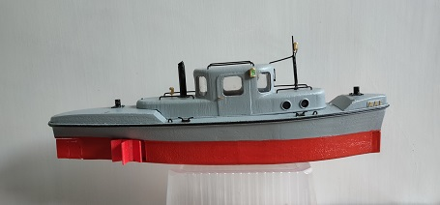
http://www.thomas-uhlendorf.de/Aal/Aal.htm

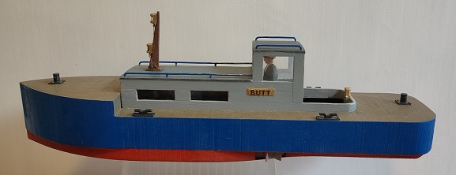
http://www.thomas-uhlendorf.de/Butt/Butt.htm
(these are only the model ships that use the paddle wheels for propulsion)

But how effective does this technique work? I have made several tests with these models to find that out, and I must conclude: It works much better than I expected. This propulsion method is nearly as effective as a propeller. Here an example:
http://www.thomas-uhlendorf.de/Moritz/MoritzRun.webm
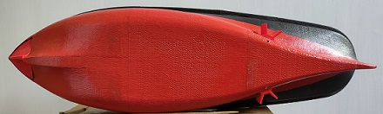
'MORITZ' is equipped with two of these partial covered paddle wheels with a vertical axle.

But that is not the only method (method 1) for fully submerged paddle wheel to function. There is also this one (method 2):
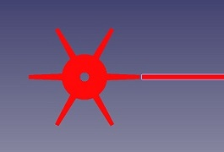
This method makes only sense with a vertical axis. The paddle wheel is no were covered, but the water movement, that a rotating paddle wheel produces, is restricted by a solid body (the hull) at one point. That means: When rotating, the paddle wheel moves water to one side of that body, producing thrust to one side.
There is no need for 6 paddles on the paddle wheel to function here. Two or even one paddle will also work.
The torque produced by this vertical paddle wheels additionally aids to steer the ship.
This method may not be always very energy efficient, but is simple, can be used on nearly any ship design and can be quite powerful.
http://www.thomas-uhlendorf.de/Aal/AalAblegen.webm

At this point I must make it clear that it is not my intent to replace the propellers as the primary means for propulsion of ships by this paddle wheels. Not at all. But: According to my investigations there are cases were this paddle wheel solution has advantages compared to propellers.

E.g. it is possible to propel a ship / boat with extremely low depth (to low for operating a propeller) with this kind of paddle wheel.
http://www.thomas-uhlendorf.de/Butt/ButtTest1.webm

But the main advantages of this technique would be in the application for bow thrusters (and stern thrusters).

Today these thrusters consist of propellers hidden in a tunnel through the ship from side to side. The disadvantage of this location for the propeller is that fluidically things become difficult when the ship moves forward (or aft) or the water flows forward or aft. At water speeds above 2 knots the effectiveness of that thruster is greatly reduced and above 4 knots it nears zero.
To still have enough thrust sideways, up to 4 bow thrusters are installed on some ships, making the bow look like Swiss cheese.
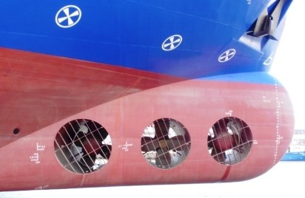
To avoid that, the 'Queen Mary 2' is equipped with valves that close its tunnels, what makes that bow thruster system even more complicated.
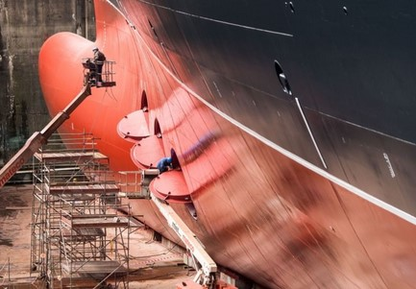
For some Offshore ships these bow thrusters anyway were found insufficient and even more complicated solution like retractable Azimuth Thrusters are considered.
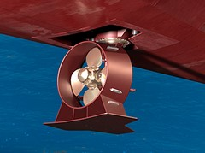
Here my paddle wheels may offer an interesting alternative solution, simple, cheap and streamlined.

The paddle wheels can be designed in many different shapes.
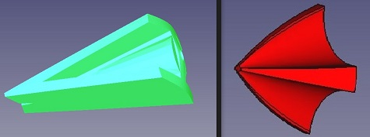
I have tried them with 6, 4, 3, 2 and even with 1 paddle. All of them work.
They can be integrated to the hull design and form a streamlined ship with no holes.
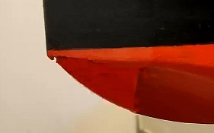
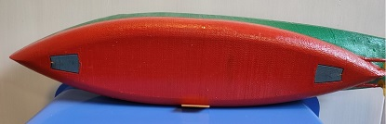
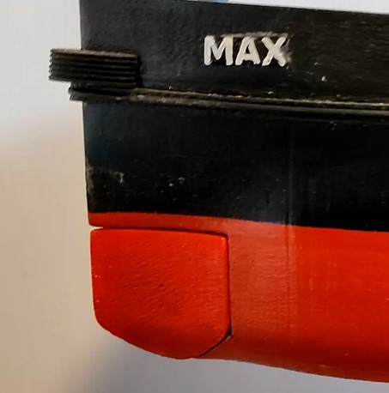
And they can be very powerful:
http://www.thomas-uhlendorf.de/Odin/OdinBowthr.webm

Also very important: The fluidically problems of conventional bow thrusters do not exist!
http://www.thomas-uhlendorf.de/Max/MaxBowrudderCruise.webm
(steering is performed here by the bow thruster only!)

In summery it can be stated that these lateral operating paddle wheels are
- very simple (only one moving part)
- very powerful
- do not loose their function at speed
- keep the hull streamlined

Maybe they should be considered for future ships!

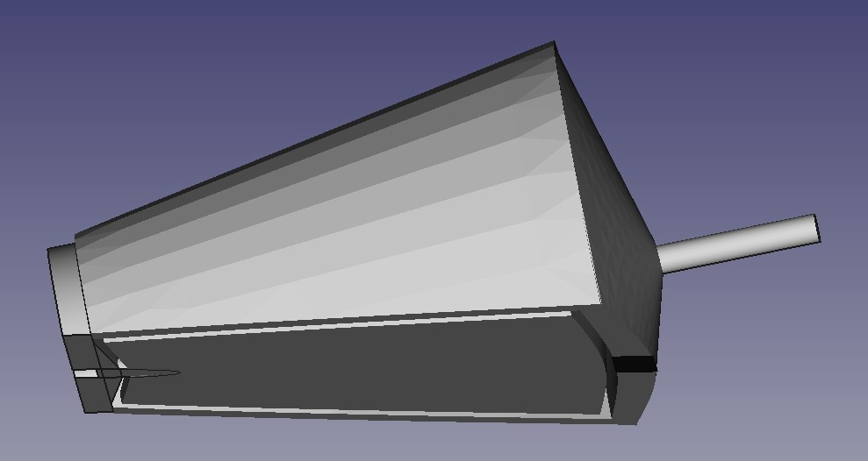

All of my experimental ships and further informations can be found here:
http://www.thomas-uhlendorf.de/Forschungsschiffe.htm

Thomas Uhlendorf

